**Day 5 SQl Assignment-B.Sreenath**

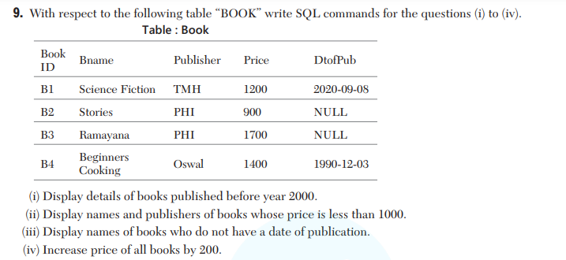

1. **SELECT * FROM book2 WHERE Dtophub >= YEAR('2000-01-01');**

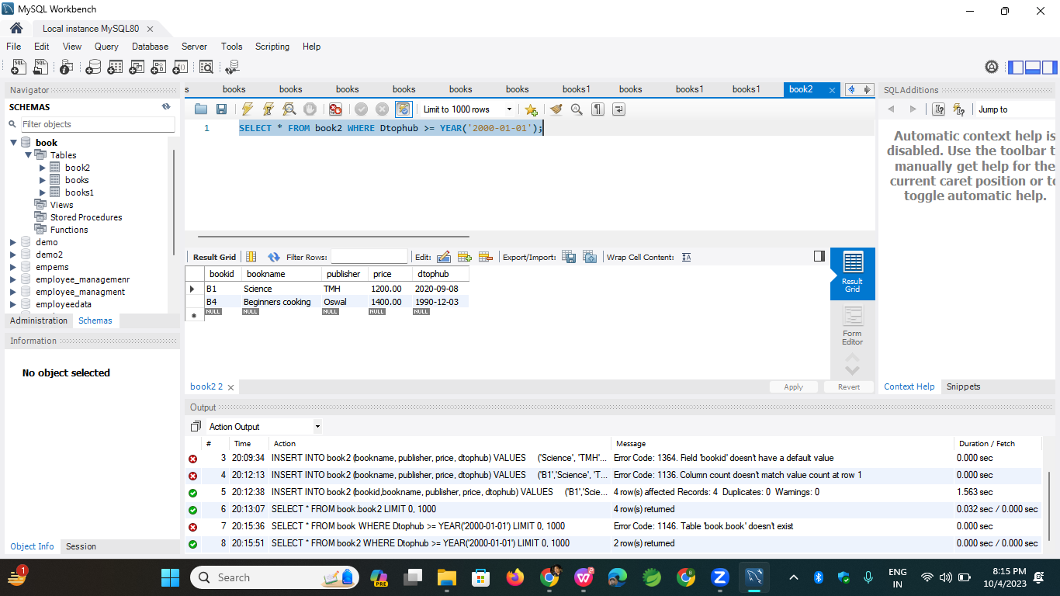

1. **SELECT bookname, Publisher FROM book2 WHERE price < 1000;**

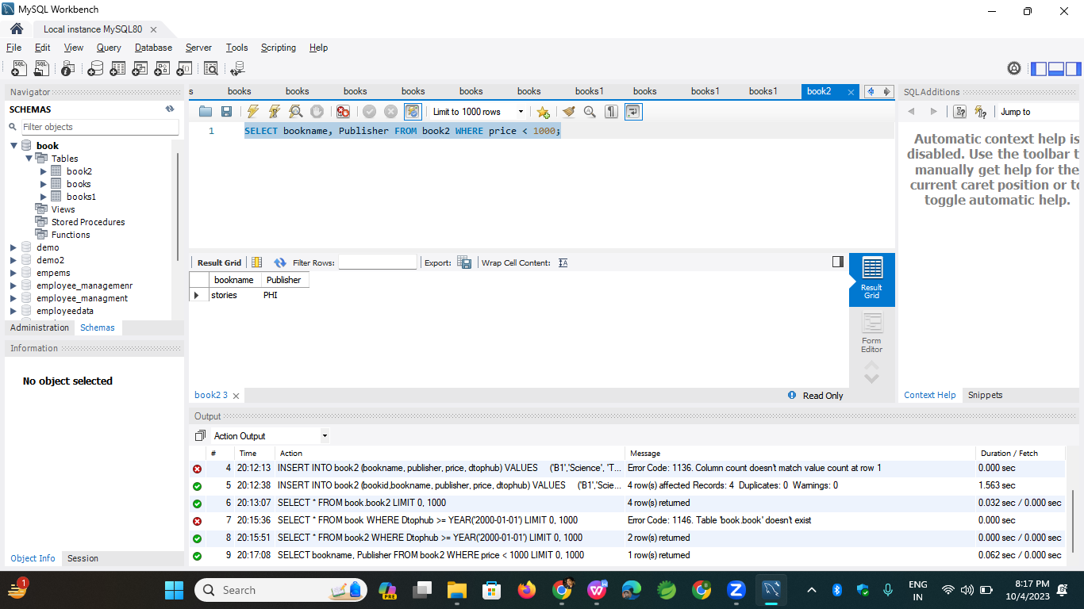

1. SELECT bookname FROM book2 WHERE Dtophub IS NULL;

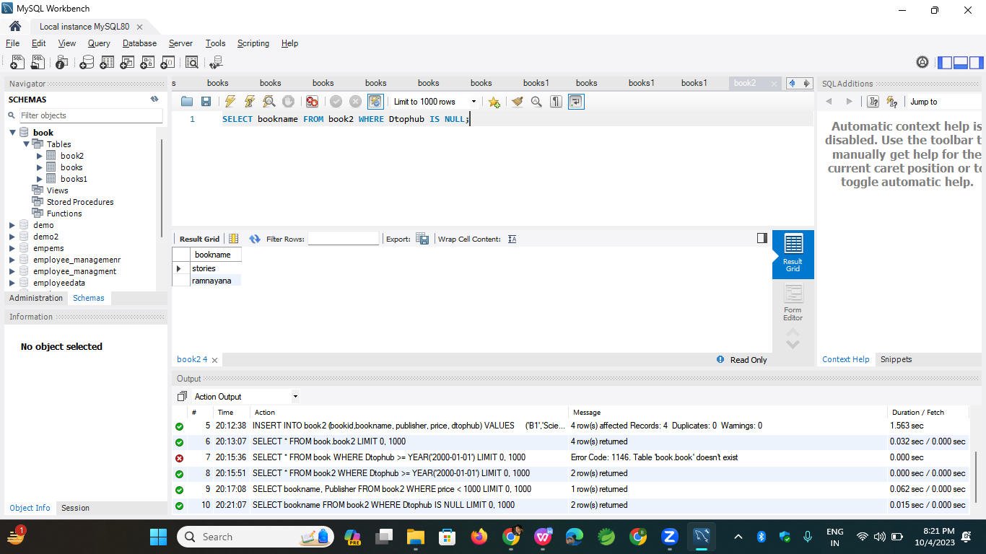

4)SELECT price+200 FROM book2;

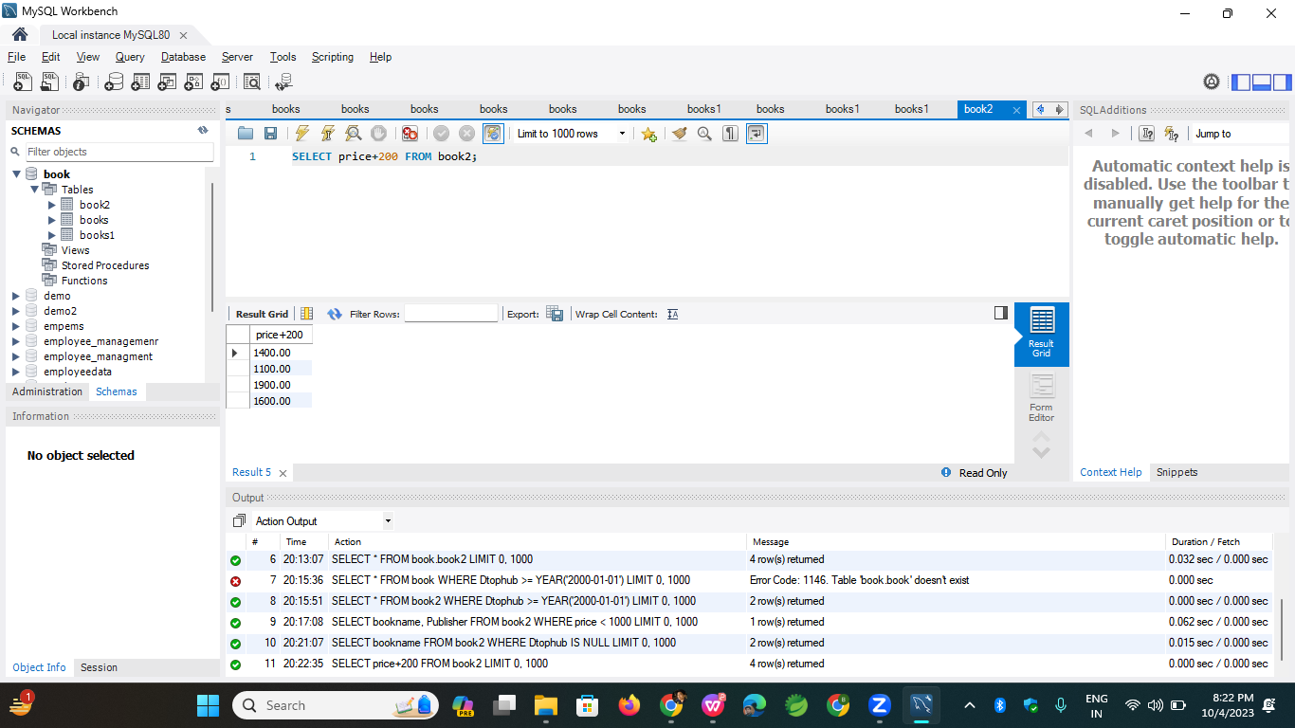

Or2)

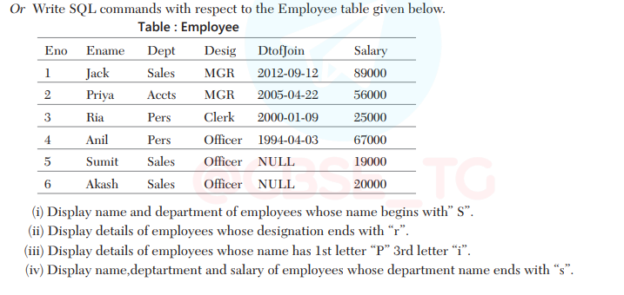

1. SELECT ename, dept FROM employee1 WHERE ename LIKE "S%";

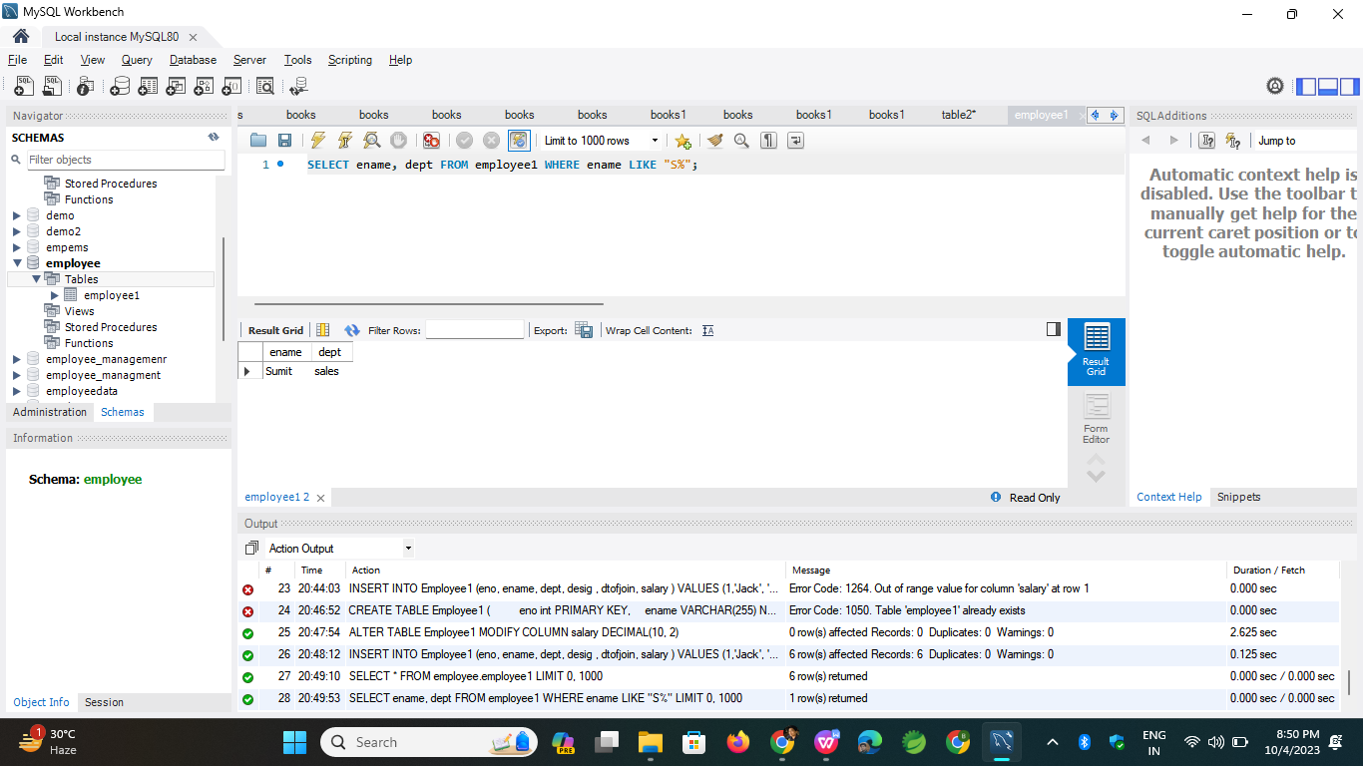

1. SELECT * FROM employee1 WHERE Desig LIKE "%r";

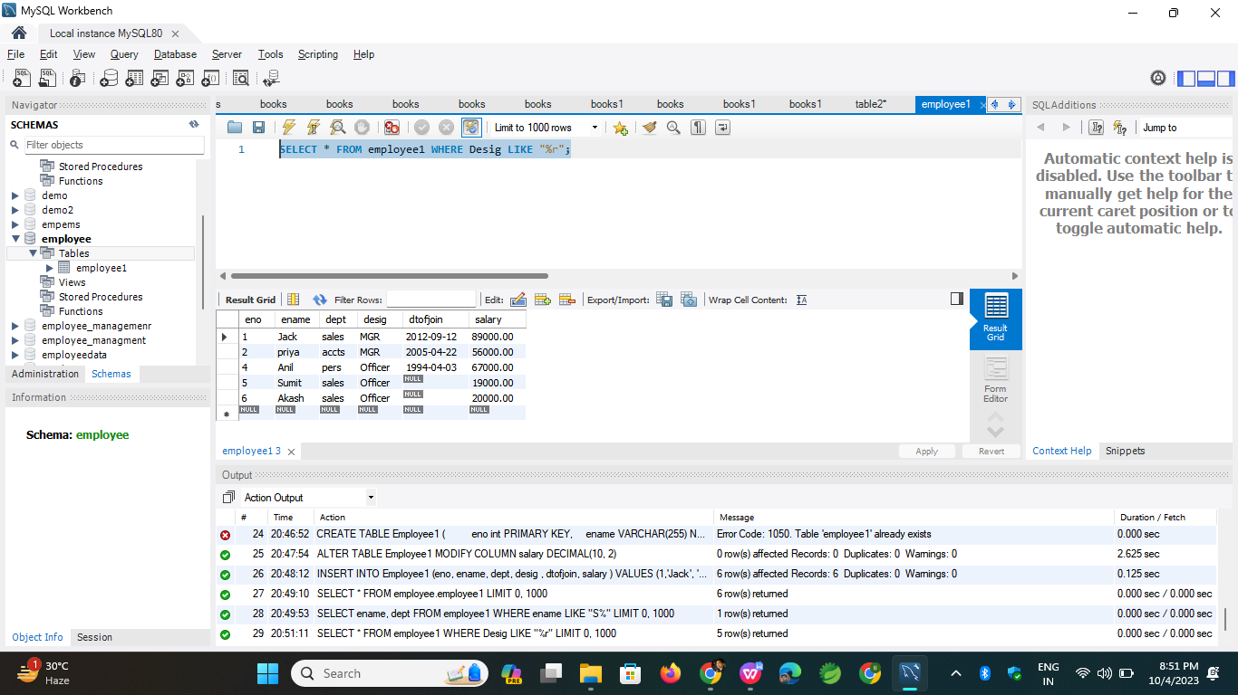

1. SELECT * FROM employee1 WHERE ename LIKE "P_i%";

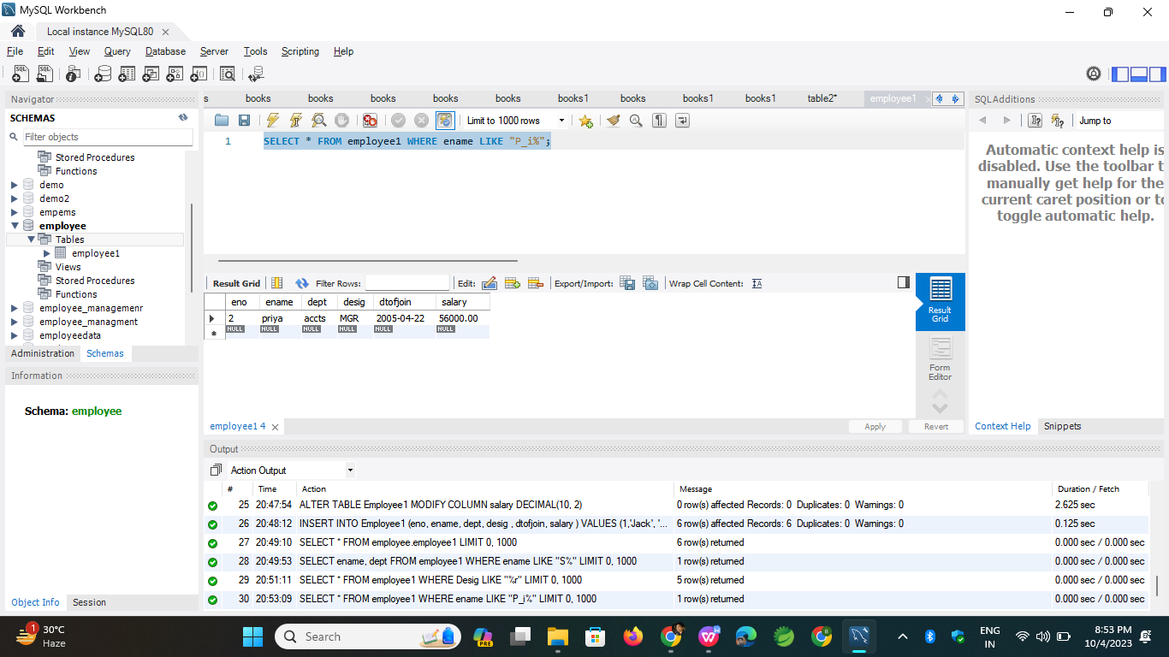

1. SELECT Ename, Dept, Salary FROM employee1 WHERE Dept LIKE "%s";

